# **Installing JASP:**

To get started using JASP, you will first need to go to:

<https://jasp-stats.org/>



Click the download JASP button. 

Pick the operating system you currently use (Windows, Mac, and Linux are available):

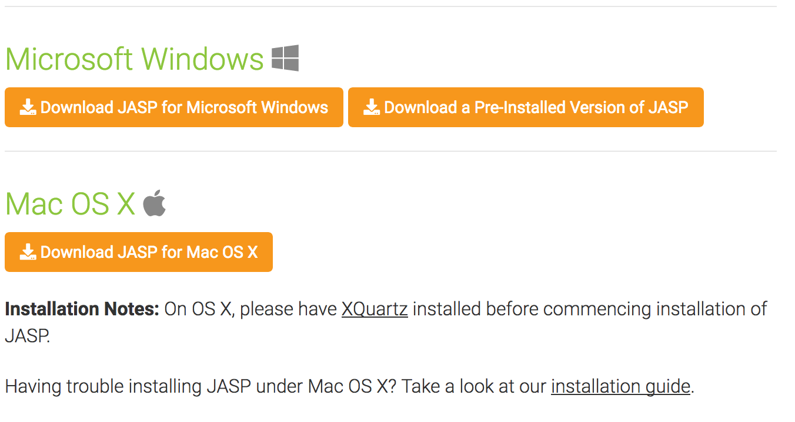

Click on the download button.

Special notes for Windows users: JASP works for Windows XP and all more recent versions. It installs under Windows like any normal application.

Special notes for Mac users: JASP is available for Mac OS X, version 10.10 (Yosemite) and above ([Which version do I have?](http://pondini.org/OSX/OSXversion.html)). JASP is installed by downloading and double clicking the .dmg file, and dragging the JASP icon to the Applications folder.

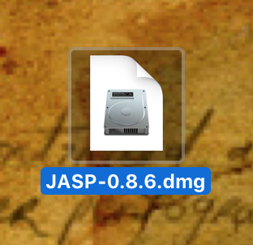

Original .dmg file downloaded from JASP website. Double-click to open.

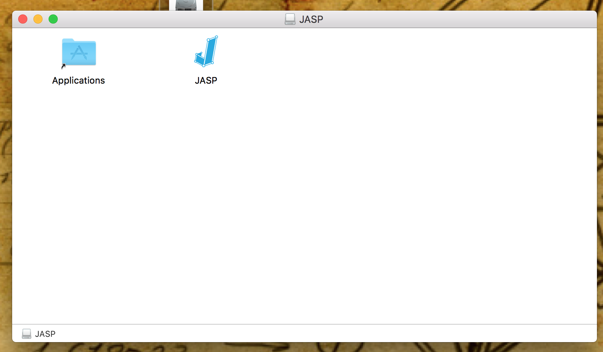

Drag the JASP icon into the Applications folder, which will install JASP into the applications folder on your Mac. OS X actively discourages people from downloading software from the internet (rather wanting to channel people through their app store), so there will likely be some additional steps to make JASP run.

Go to applications and double click on JASP. You may get the following message:

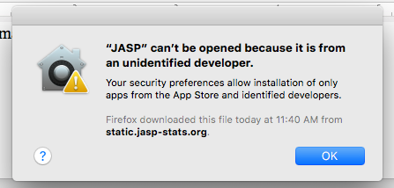

To allow your Mac to open JASP, you will need to go to System Preferences. Click on the search icon  in the upper right hand corner of your Mac.

Start typing system … to see system preferences and click on the first option.

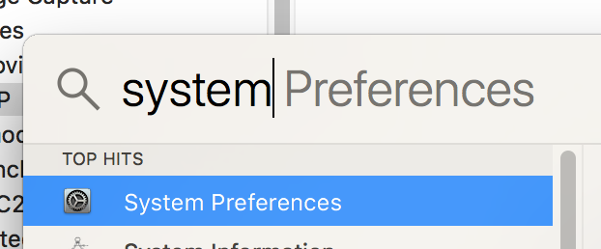

In the top row, click on security and privacy 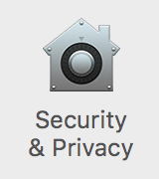. Because you just tried to open JASP, you should see this message:

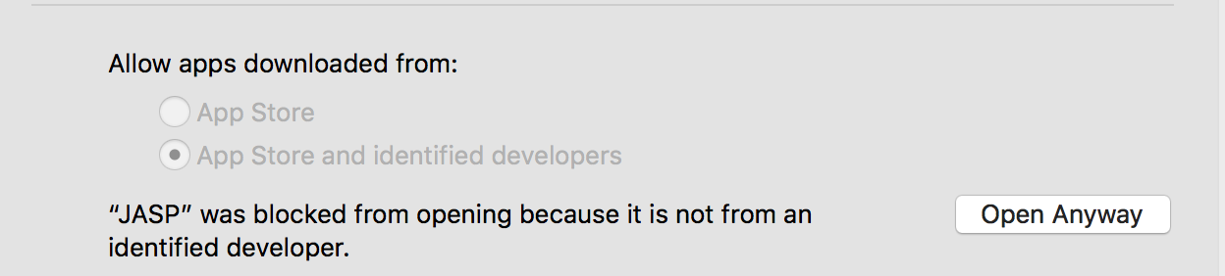

Click open anyway .

You should now get this message about JASP from an unidentified developer:

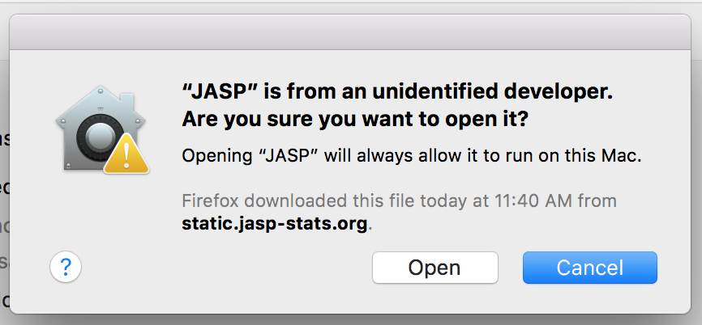

Click open .

JASP should now open. You should not have to do this process again unless you install a new version.